
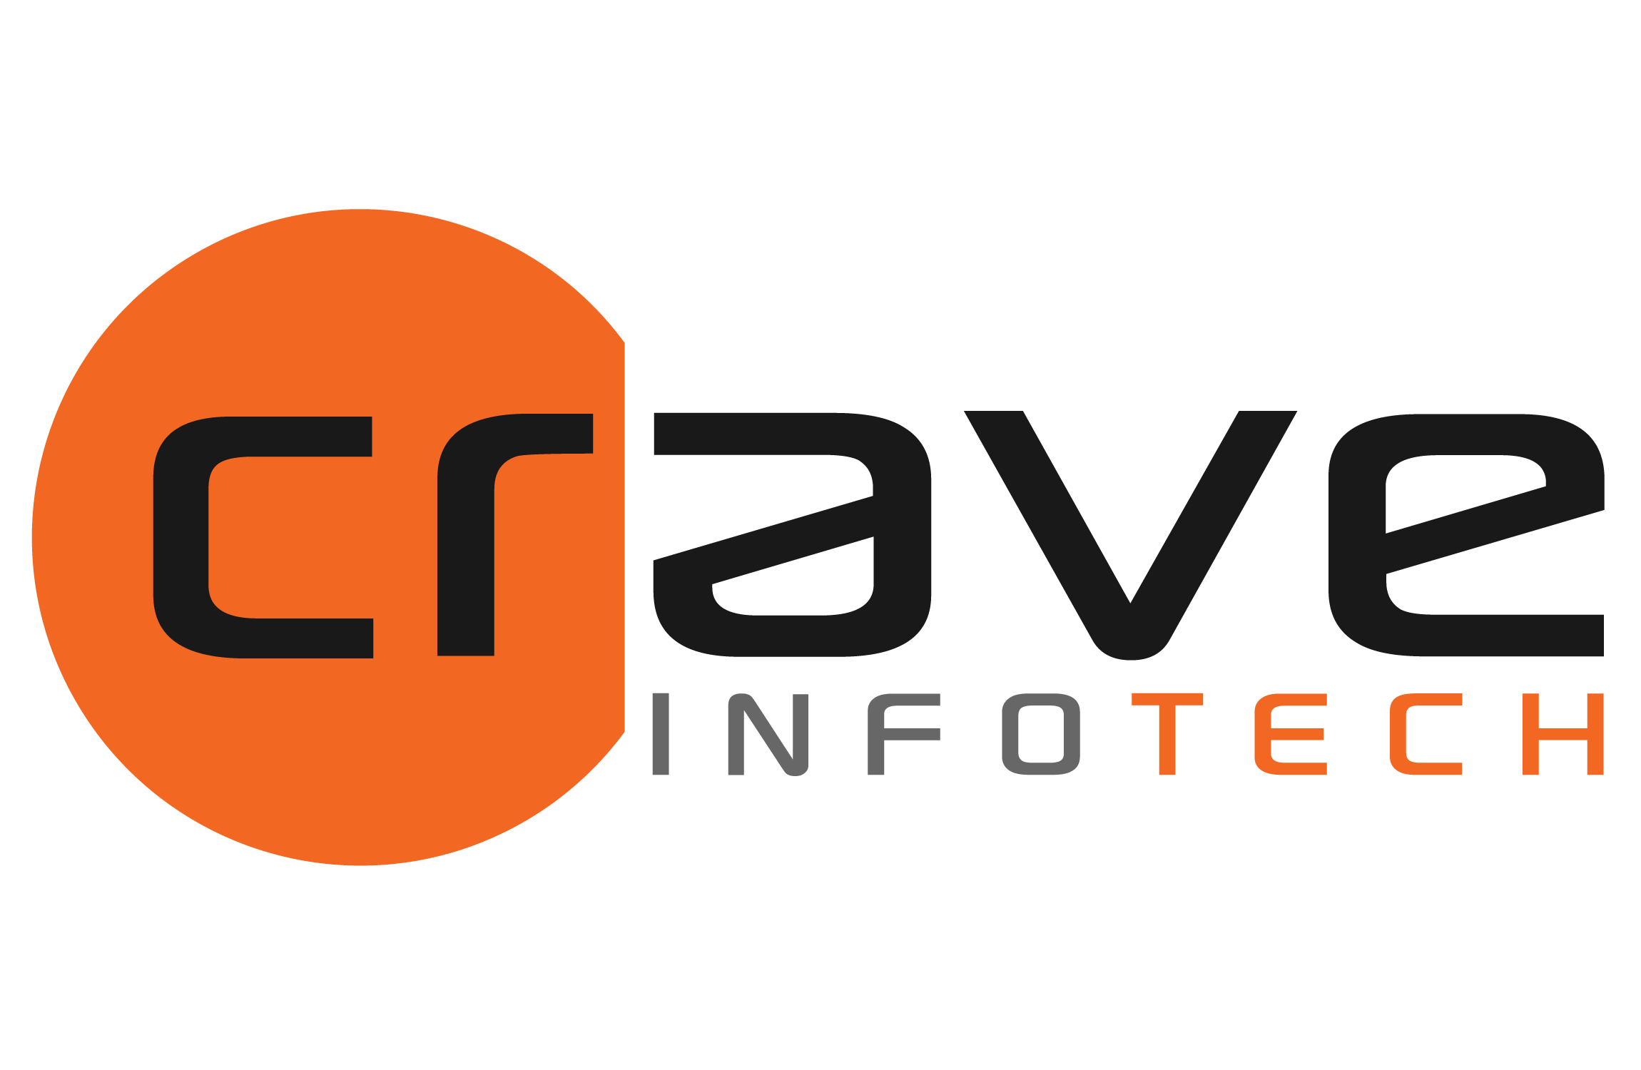

SOW
for
PI/PO Interface Migration
for
<Client Name>

Submitted on: 15 August 2024
Version: 1.0

By:

Crave InfoTech
2035 Lincoln Highway, Suite3008D, Edison NJ 08817

Point of Contact:
Shrikant Nistane
Contact: +1 253 241 6704
Email: Shrikant@craveinfotech.com

Kalpana Parekh
Contact: +1 416 688 0297
Email: Kalpana@craveinfotech.com

Table of Contents
1. Executive Summary 3
2. Objective 4
Objective 4
3. Scope and Out of Scope 5
In Scope: 5
Migration Project Prerequisites: 5
Assumptions: 5
Out of Scope: 5
4. Implementation Approach & Timelines 6
Migration Methodology from PI PO to Integration Suite 6
Proposed Timeline – 17 weeks 7
5. Responsibility Matrix 8
6. Resource Schedule, Charges and Payment Terms 9
Resource Schedule 9
Commercials: 9
Timesheet, Invoices and Payment Terms 10
7. Governance (Meetings/Steercos/Escalation Path) 11
Communication Plan 11
Issue Resolution and Escalation Procedure 11
8. Sign Off 13
9. Appendix 14

Executive Summary
<<EXEC_SUMMARY>>

<<AWARDS>>
Sustainability:
At Crave InfoTech, we recognize the importance of sustainability in fostering long-term growth, innovation, and responsibility. As a leading player in the IT sector, we are committed to integrating sustainable practices into every aspect of our business. Our approach to sustainability is guided by the principles of environmental stewardship, social responsibility, and economic viability.

Ecovadis Rating for Crave InfoTech
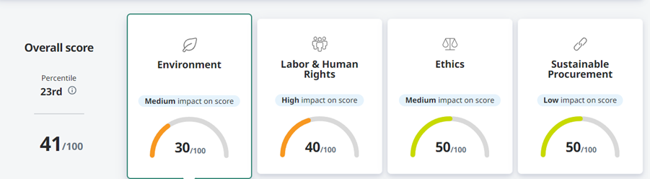

Objective
<<OBJECTIVE>>

Scope and Out of Scope
<<SCOPE_TEXT>>

Implementation Approach & Timelines
Crave InfoTech's migration methodology has been incorporated with multiple implementation experiences. Our methodology is based on lean principles and adapts to implementation needs. We have delivered multiple BTP projects successfully with this approach.

Migration Methodology from PI PO to Integration Suite
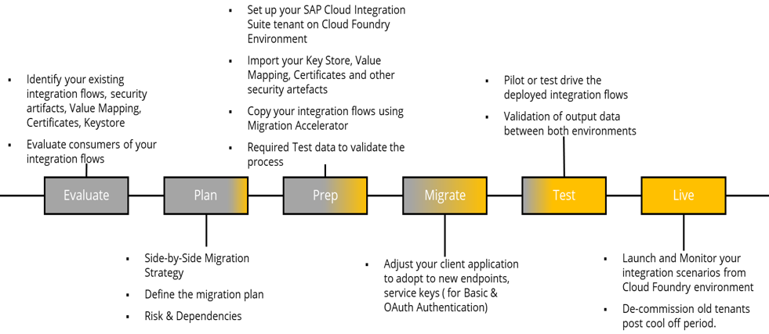
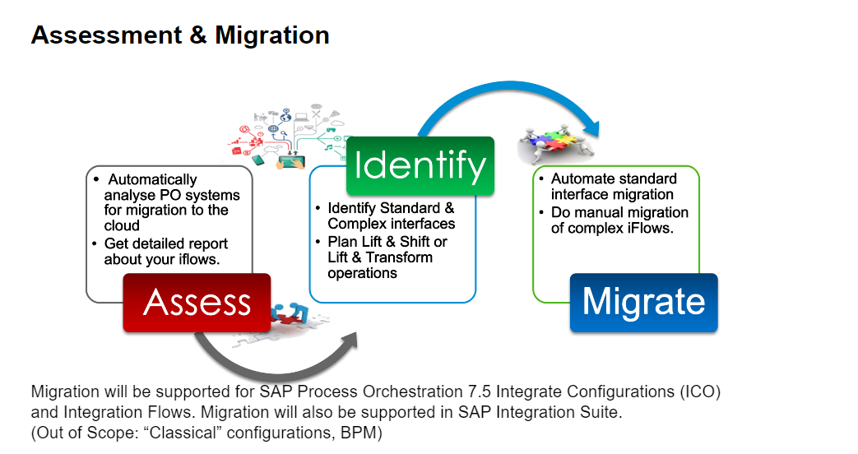
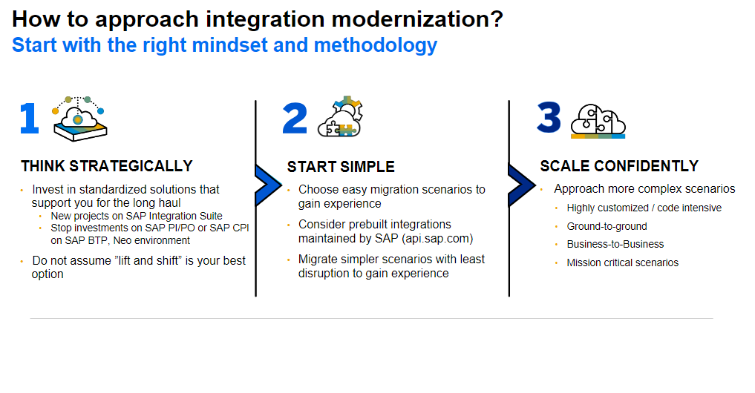

Proposed Timeline –

**Please Insert Project Plan

Responsibility Matrix
The definition of the responsibilities of the team members in the delivery organization including Crave InfoTech and Client Organization is critical to the project's success.

**Please add Responsibility Table here

Resource Schedule, Charges and Payment Terms
<<RESOURCE_SCHEDULE>>

Governance (Meetings/Steercos/Escalation Path)
<<COMMUNICATION_PLAN>>

Sign Off
IN WITNESS WHEREOF, Crave InfoTech and <ClientName> have each caused this Project Proposal to be executed by their respective duly authorized officers as of the Effective Date.
The undersigned agree to the terms of this proposal on behalf of his or her organization or business.

<ClientName> Crave Infotech
By: By:
Authorized Signature Authorized Signature
Name: Name: Vrushali Nistane

Date: Date:

Appendix

